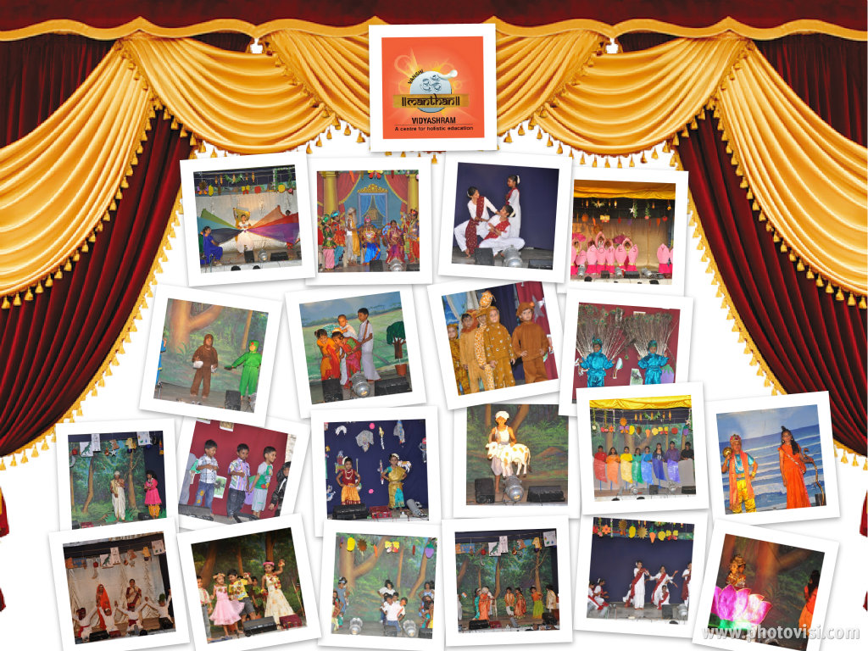

|  |  |
| --- | --- |
| **Vanshi Manthan Vidyashram**  2/155, Natco Colony North Street, Kottivakkam, Chennai 600 041.  Tel: 2448 5979/99419 11159 | |
| **Annual Day 2013-14** | |
| Dates | **April 4 , 2014 (Friday)**  **April 5 , 2014 (Saturday)** |
| Programme Time | **5.30 pm – 7.30 pm** |
| Reporting Time | **5.00 pm** |
| Venue | **Manthan Vidyashram** |
| Important | **Every child is participating. Manthan invites all parents, grandparents and well wishers to come and encourage our children on both days.**  **Send dry snacks and water in a basket with a name tag.** |
| Parking Vehicles | **Parking space is limited due to Phase III construction @ Manthan. Parking inside Manthan is on First Cum First Serve basis.**  **Others to park their vehicle in Natco Colony / Natesan Colony without being an hindrance to the local residents. Do not park in front of gates** |

**Amritotsava**

**Vanshi Manthan Vidyashram**

**Vanshi Manthan Vidyashram**

 

**Chief Guests:**

**Mr. Anand Narayanan**

**Mrs. Anjana Anand**

**Chief Guests:**

**Mr Balamurugan**

**Mrs. Vino Balamurugan**

**Fan dance of Vietnam**

**Chale Chalo \***

**Frolicking on a Rainy day**

**Dancing with Tulips**

**Check Mate \***

**Sambhaji's Sambar**

**Panchayat Theerpu**

**I'm Just Like You**

**I Believe I Can fly**

**Fun Filled Sunday**

**Zoomi Zoomi's Buried Treasure**

**Welcome Dance**

**Walking in the Jungle**

**Vanga Vilayadalam**

**Save our Trees, Save Ourselves**

**Sarva Shiksha Abhyan**

**Pattikada Pattinama**

**Prelude - Kolakolaiya Mundrika**

**Paasimani Oosimani**

**Oora Kakkum Samy**

**Kasmiri Masti**

**Kanaada Prathignya**

**Indian Railways**

**Welcome Back Home**

**Thai Poranthal Vazhi Porakkum**

**Surfing on the Waves**

**Prelude Sambhaji's Sambar**

**Prelude - Doodh Ki Nadhi**

**Kathak Fusion**

**Doodh Ki Nadhi**

**Events on**

**April 5th**

**Events on**

**April 4th 2014**

**\* Events listed in the alphabetical order** 